**PHP processing:**

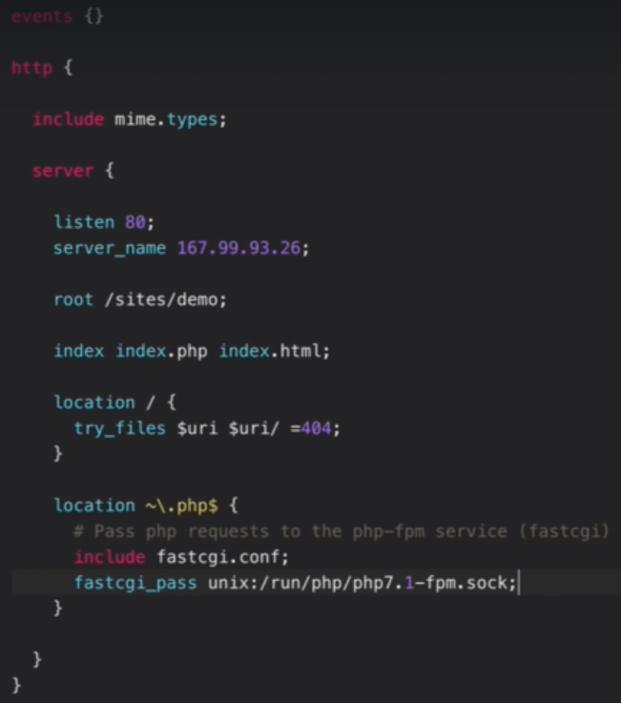

* We can do the configuration as above for the connection to PHP. We need to find that sock file location and add it. Save it and reload
* As above, nginx check .php files first and then .html files.
* once we hit the URL, we can see the PHP data in browser.

**Worker processes:**

* We can increase the worker processes in configuration file as below.

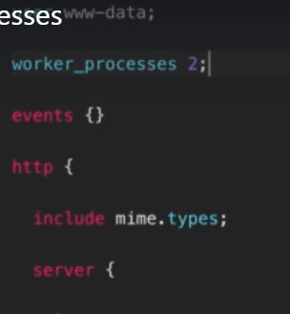

* After saving and reloading the configuration. We can see nginx is running two worker processes.

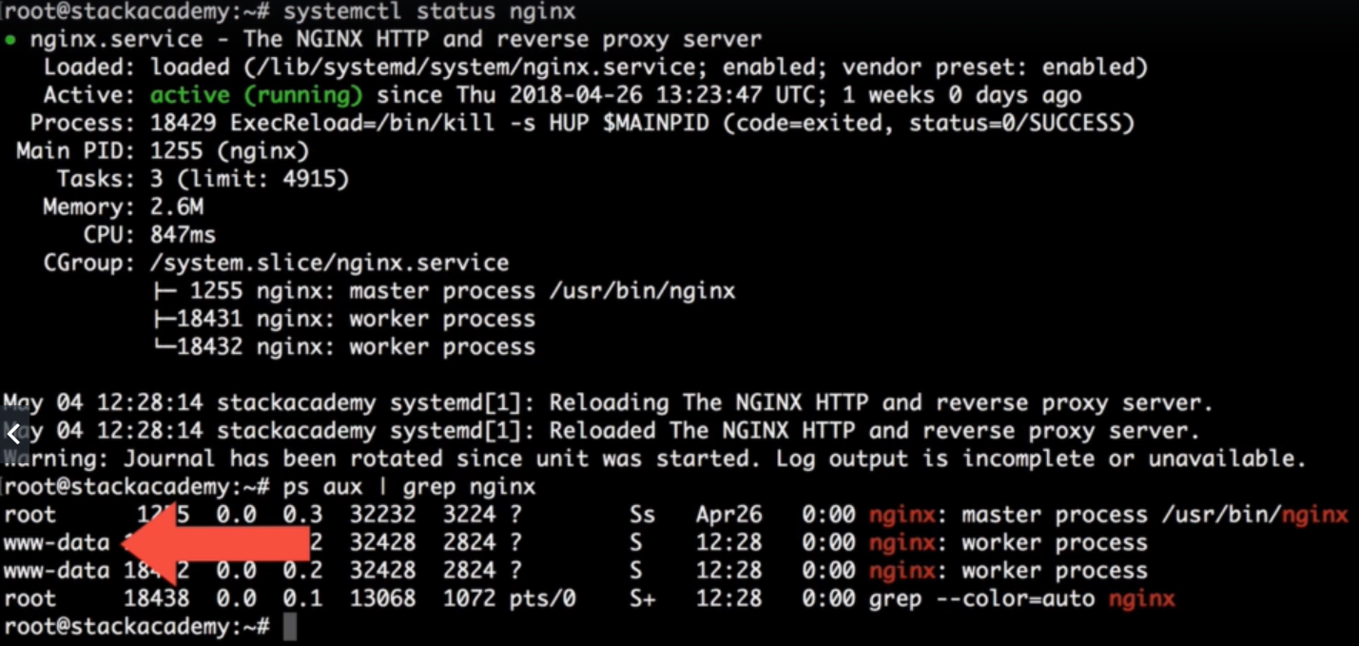

* Increasing the worker processes handling requests as fast as the hardware ability
* Simply adding the second worker process doesn’t increase the performance.
* If we have 4 cores in the server. Nginx won’t share the worker processes between the cores. There will be only one process runs per core. So, we can define the worker processes based on the cores we have in server. If we have 4 cores, go for 4 processes.
* Instead of two worker processes in a single core running with 50% capable of each process. We can can have a single process running 100% in a core.

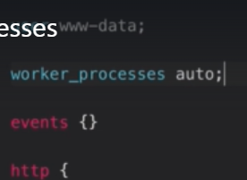

* We can simply give the worker processes as auto. So that the nginx will automatically assign the worker process each for a core based on the server configuration.

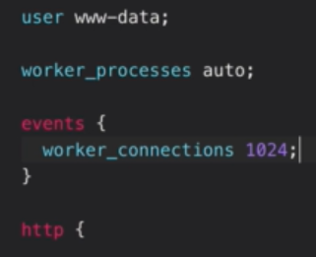

* Worker connections is other thing which we can give per process based on the server capacity
* We can get this number from server with **“ulimit -l”** command.

**Pid:**

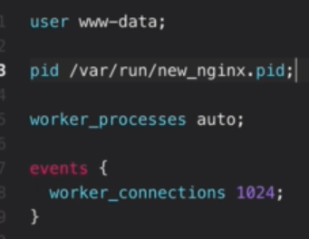

* By default, **nginx pid** location is **“/var/run/nginx.pid”.** if we want to change it. We can use the above pid configuration in **nginx.conf** file.
* Save it and reload. We can see that new pid file in given location.